Amicus is committed to safety and wellbeing of all children and young people. This will be the primary focus of our care and decision-making. Amicus has zero tolerance for child abuse.
This commitment is intended to empower children and young people, who are vital and active participants at Amicus. Children and young people are involved in decision making that directly affects them. Amicus listens to children and young people’s views and respect what they have to say.
Amicus is committed to providing a child safe environment where children and young people are safe, feel safe, and their voices are heard about decisions that affect their lives.
Amicus promotes diversity and tolerance within the organisation, and people from all walks of life and cultural backgrounds are welcome.
- Amicus is committed to child safety – WE HAVE ZERO TOLERANCE TO CHILD ABUSE
- Amicus is committed to the cultural safety of Aboriginal children and young people, the cultural safety of children and young people of diverse backgrounds, and to providing a safe environment for LGBTIQA+ children and young people and children and young people with a disability. We acknowledge the individual experience of Aboriginal children and young people with respect.
- Amicus policy and procedures promote equity and respect for child safety and wellbeing at all levels of the organisation. All policy and procedures are regularly reviewed.
- Amicus ensures all children and young people are informed of their rights and are included in decision making. They are respected and always heard.
- Amicus promotes safe environments to ensure all children and young people are comfortable and empowered to express their individuality.
- Amicus is committed to engaging with families and the community about the safety, wellbeing and empowerment of all children and young people.
- Amicus has robust human resources and recruitment practices for all staff and volunteers with regular review and supervision.
- Amicus is committed to regular training and educating staff and volunteers on record keeping, information sharing and reporting obligations.
- Amicus process for complaints and feedback is child and young person friendly and all complaints will be treated seriously.
- Amicus is committed to ensuring safety of children and young people in both physical and online environments.

If you believe or suspect a child is at immediate risk of abuse phone 000.

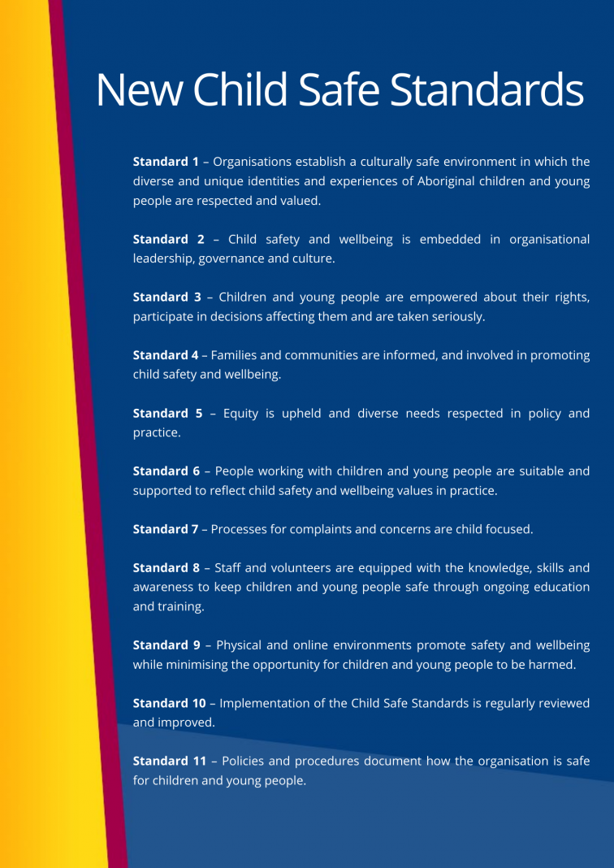

For further information, please see https://ccyp.vic.gov.au/child-safe-standards/
